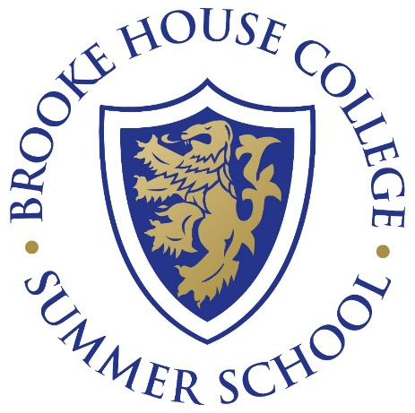

**Evening Trip to a West End Musical**

Cost - £190.00 per person

|  |  |
| --- | --- |
| **Time** | **Activity** |
| 13:30 – 16:00 | Travel to London |
| 16:00 – 17:15 | [Covent Garden](https://www.coventgarden.london/) |
| 17:30 – 19:00 | Dinner |
| 19:30 – 22:30 | [West End Show](https://www.londontheatre.co.uk/whats-on) |
| 22:30 – 01:00 | Travel to Market Harborough |

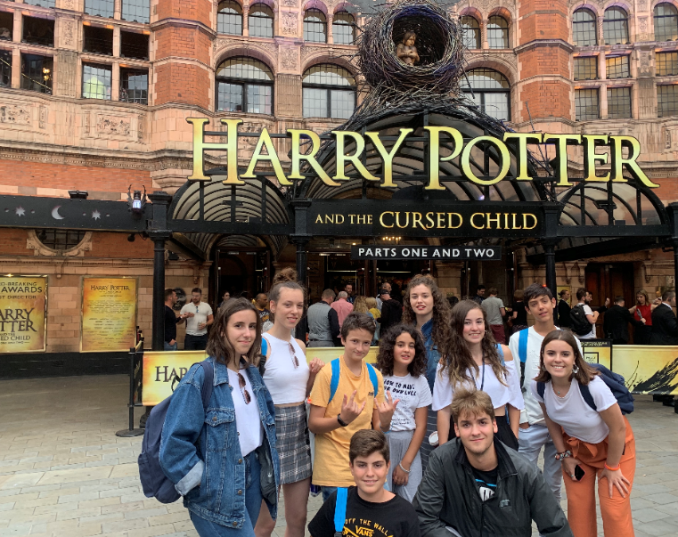

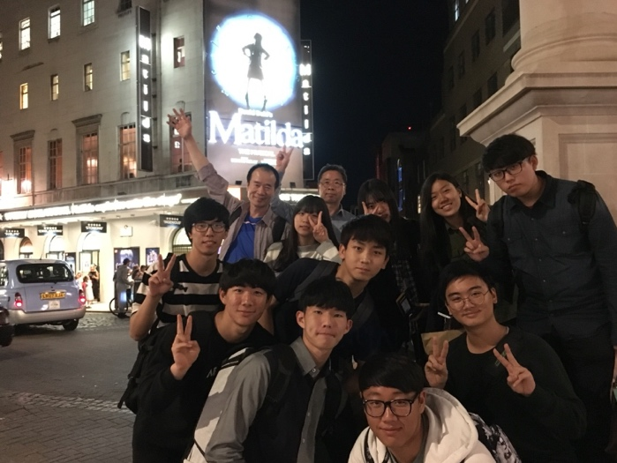

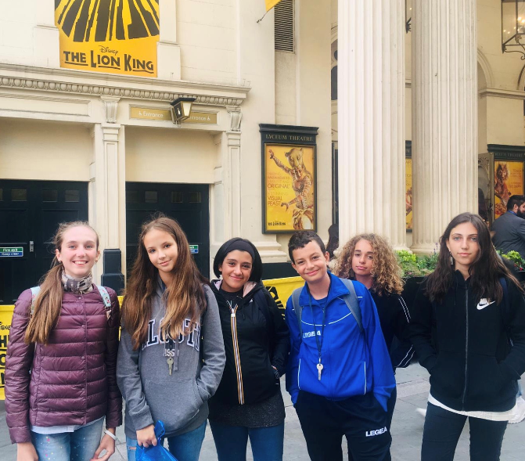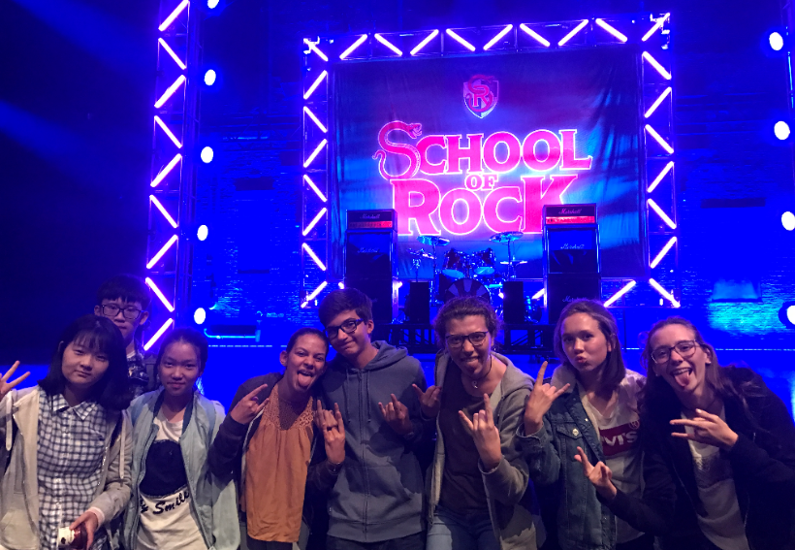

Cost - £125.00 per student – inclusive of attractions, meals, tours & transport.

Register – Email [summerschool@brookehouse.com](mailto:summerschool@brookehouse.com)